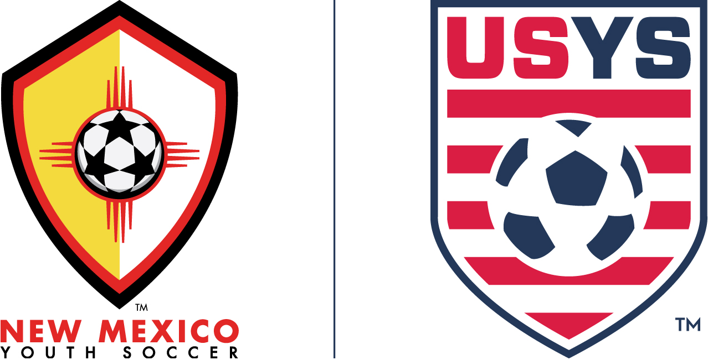

**Cyberbullying**

I acknowledge that Cyberbullying, or any other form or harassment through social media platforms*, is strictly prohibited by NMYSA and that this prohibition applies to players, parents, spectators, coaches, administrators, volunteers and officials. Cyberbullying” is defined as any electronic communication that:

(1) targets a specific player, coach, parent, employee, contractor, referee, volunteer, or person not defined herein;

(2) is published with the intention that the communication be seen by or disclosed to the targeted person described in (1) above;

(3) is in fact seen by or disclosed to the targeted person; and

(4) creates or is certain to create a hostile playing and/or social environment that is so severe or pervasive as to substantially interfere with the targeted person’s opportunities or performance in NMYSA-sanctioned events; or

(5) creates or is certain to create a hostile working and/or social environment for participants in NMYSA sanctioned activities.

(6) is inappropriate for youth participants.

*Social media platforms are defined here to include all websites and applications that enable users to create and share content or to participate in social networking.

Offenders of this policy will be asked to remove the content from social media platforms and may be subject to sanctions number NMYSA procedures and rules.

Please note, your league and/or club may have additional policies concerning Cyberbullying.